## Supplementary Material

A. Data and distribution

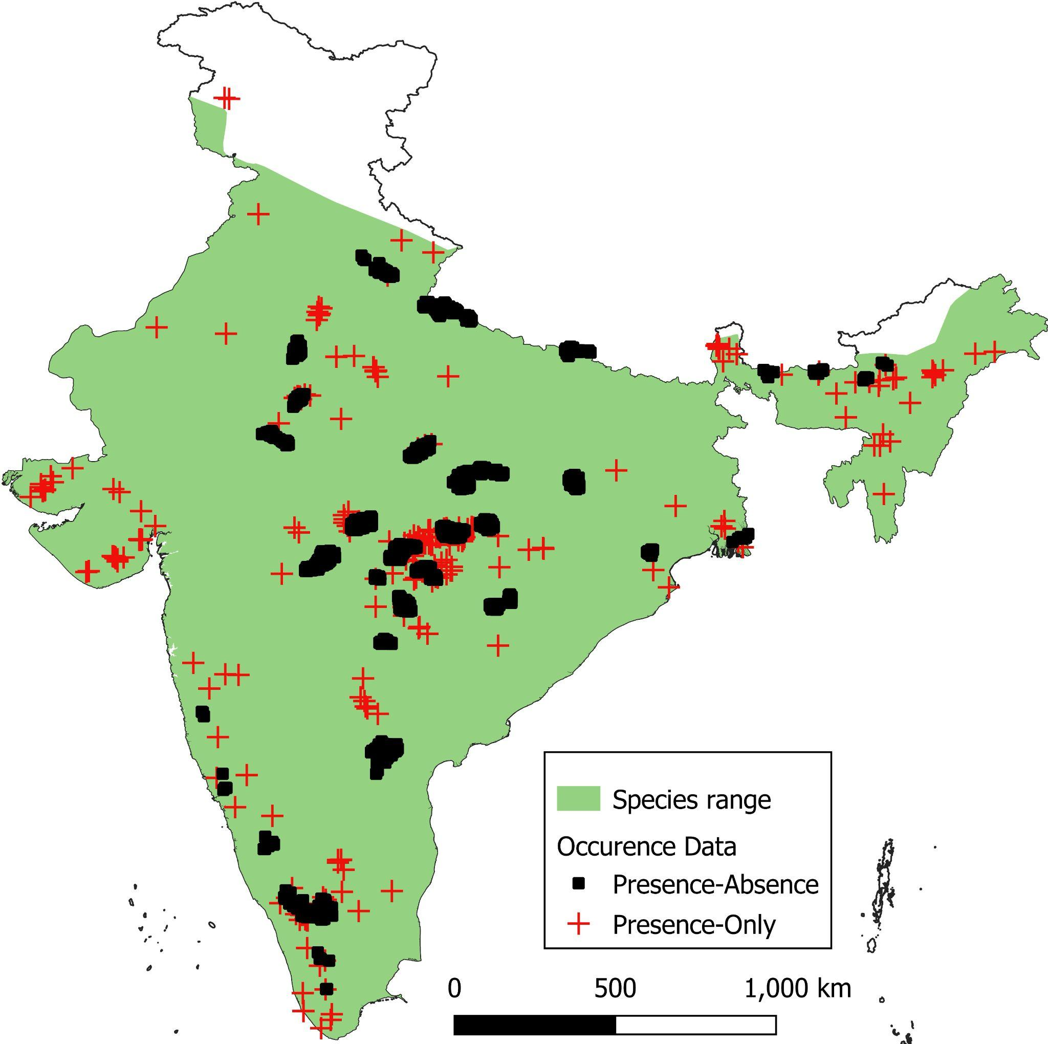

**Figure A1. Distribution of Jungle Cat in India and the two types of occurrence data.**

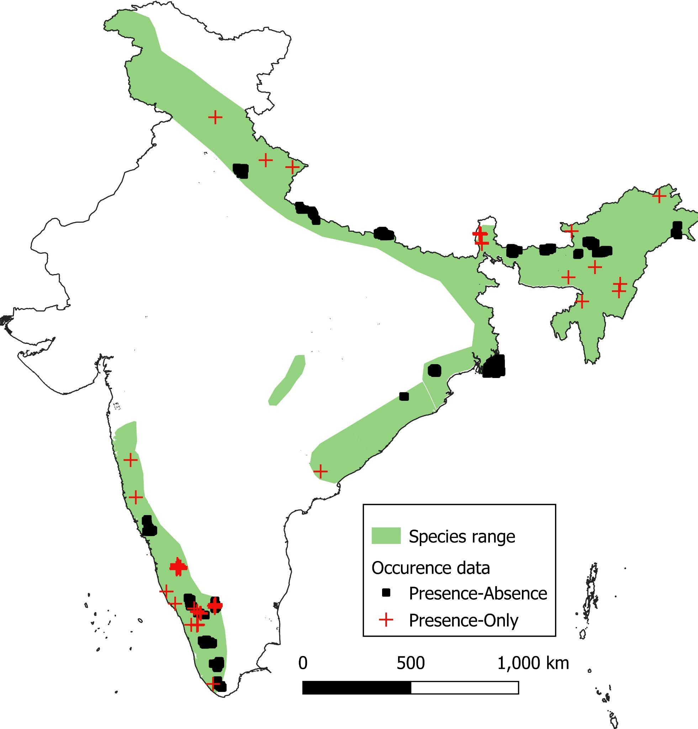

**Figure A2. Distribution of Leopard Cat in India and the two types of occurrence data.**

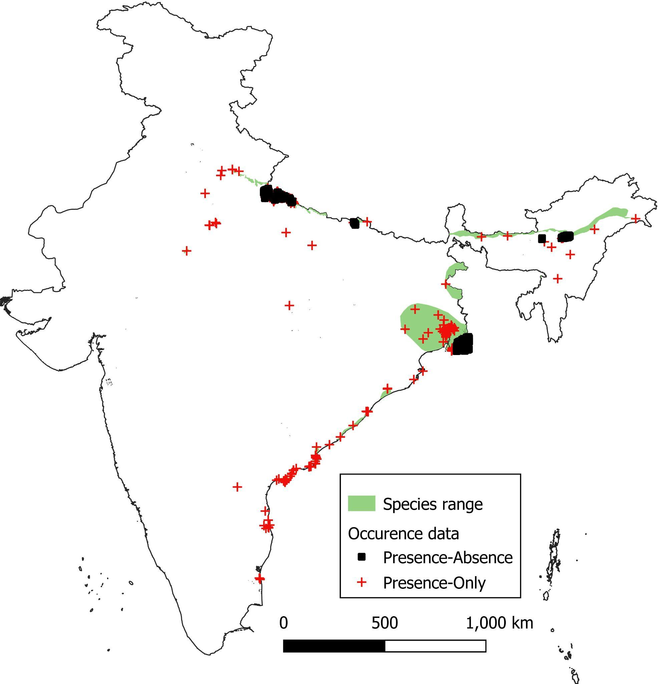

**Figure A3. Distribution of Fishing Cat in India and the two types of occurrence data.**

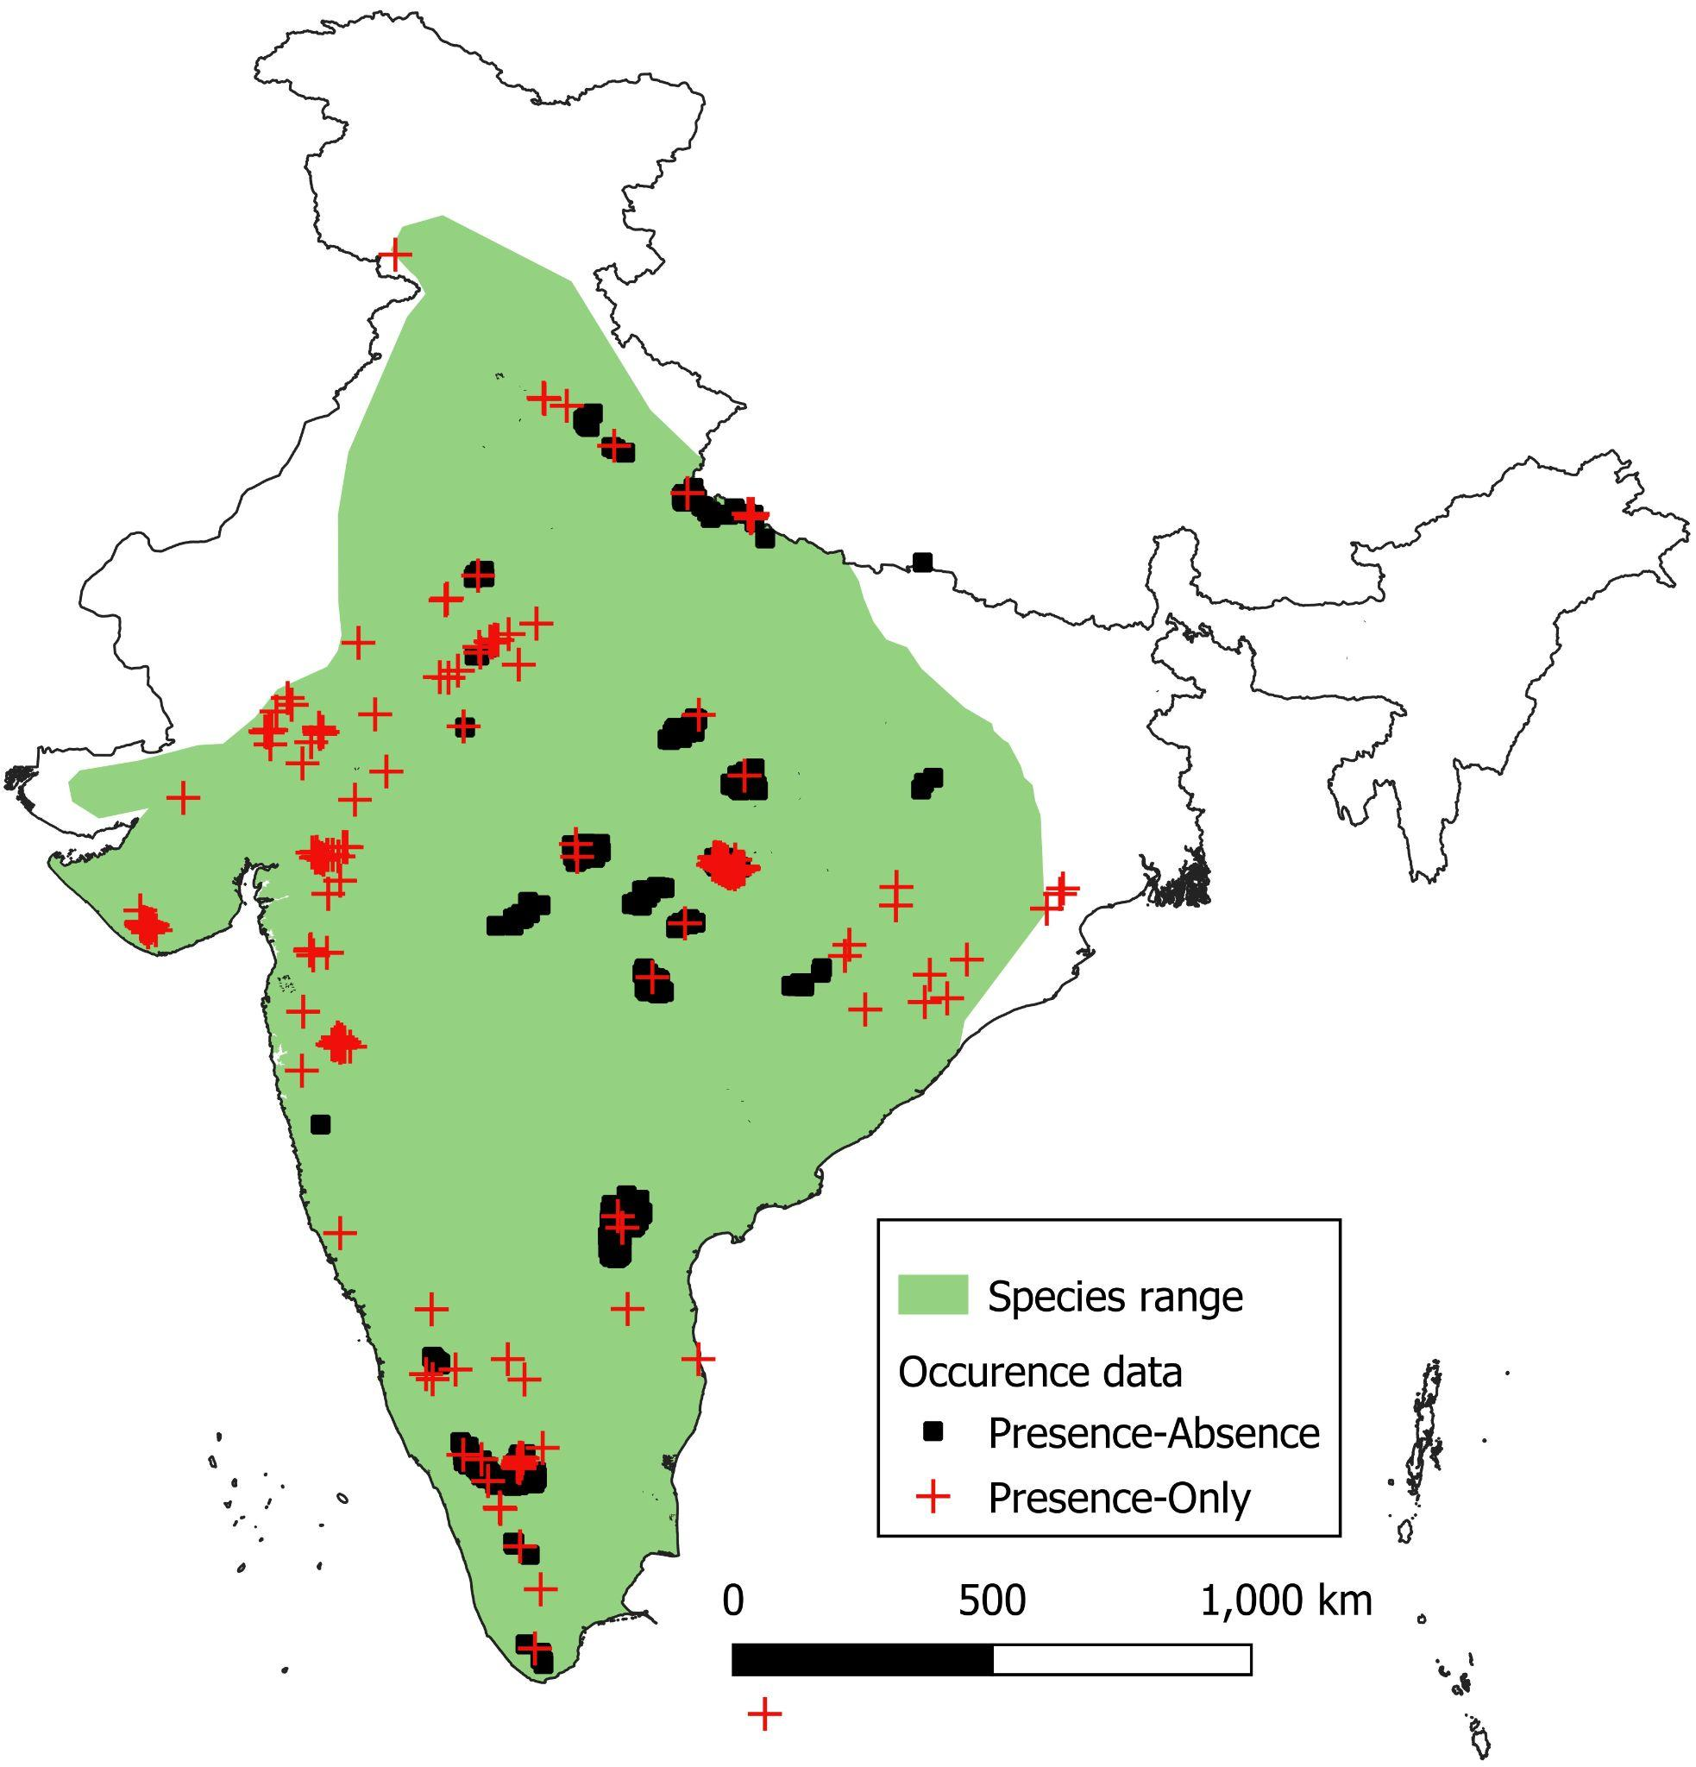

**Figure A4. Distribution of Rusty-spotted Cat in India and the two types of occurrence data.**

B. Species distribution prediction maps

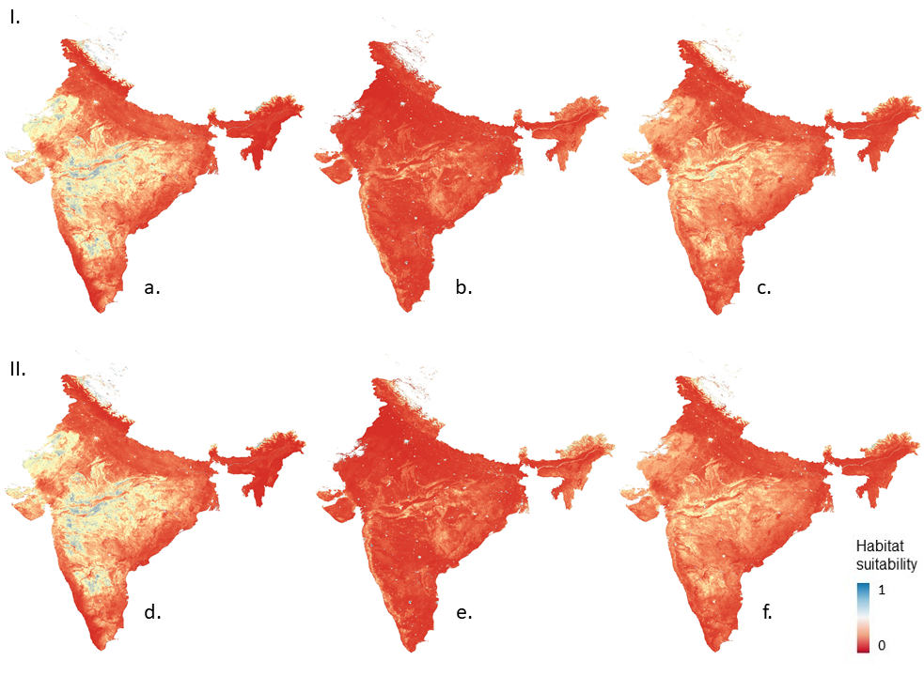

**Figure B1. Species distribution prediction maps for Jungle Cat across India using models with different sampling extent (I. India extent, II. Range extent) and datasets (a and d - PA, b and e - PB, c and f - average).**

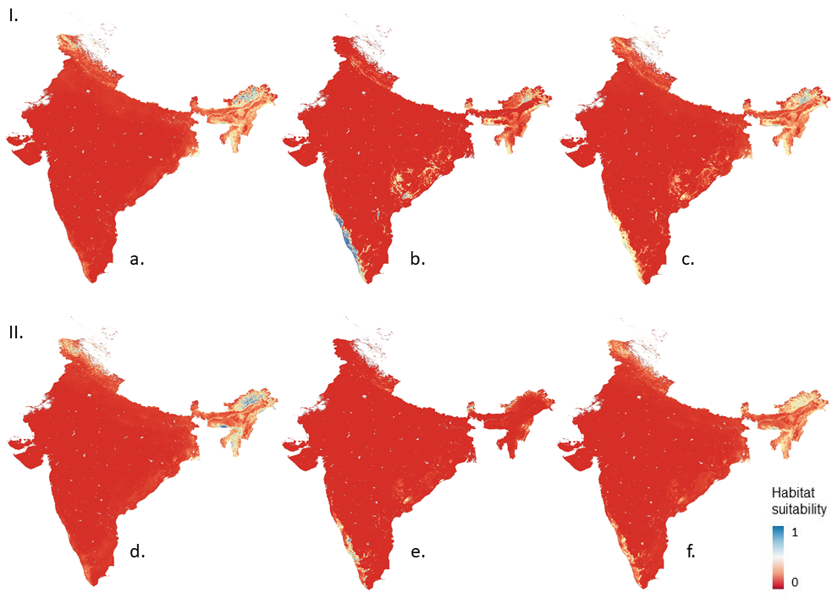

**Figure B2. Species distribution prediction maps for Leopard Cat across India using models with different sampling extent (I. India extent, II. Range extent) and datasets (a and d - PA, b and e - PB, c and f - average).**

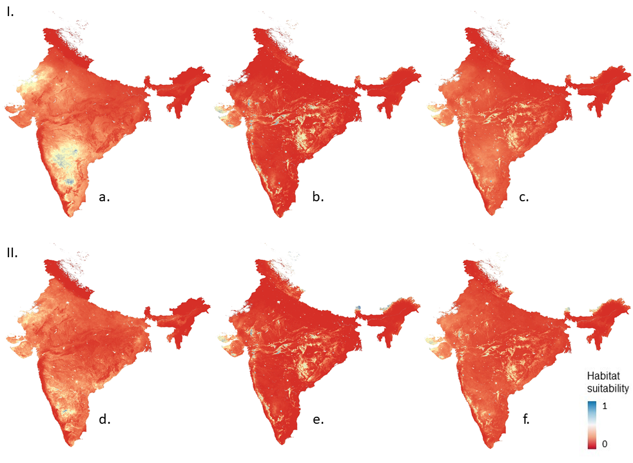

**Figure B3. Species distribution prediction maps for Rusty-spotted Cat across India using models with different sampling extent (I. India extent, II. Range extent) and datasets (a and d - PA, b and e - PB, c and f - average).**

C. Diagnostic Analysis

**A-c presents differences in the presence (a) and absence data (b-c) between PA and PO models, d-e presents differences in absences when sampling for India and species range, and f presents the range of the species within the country.**

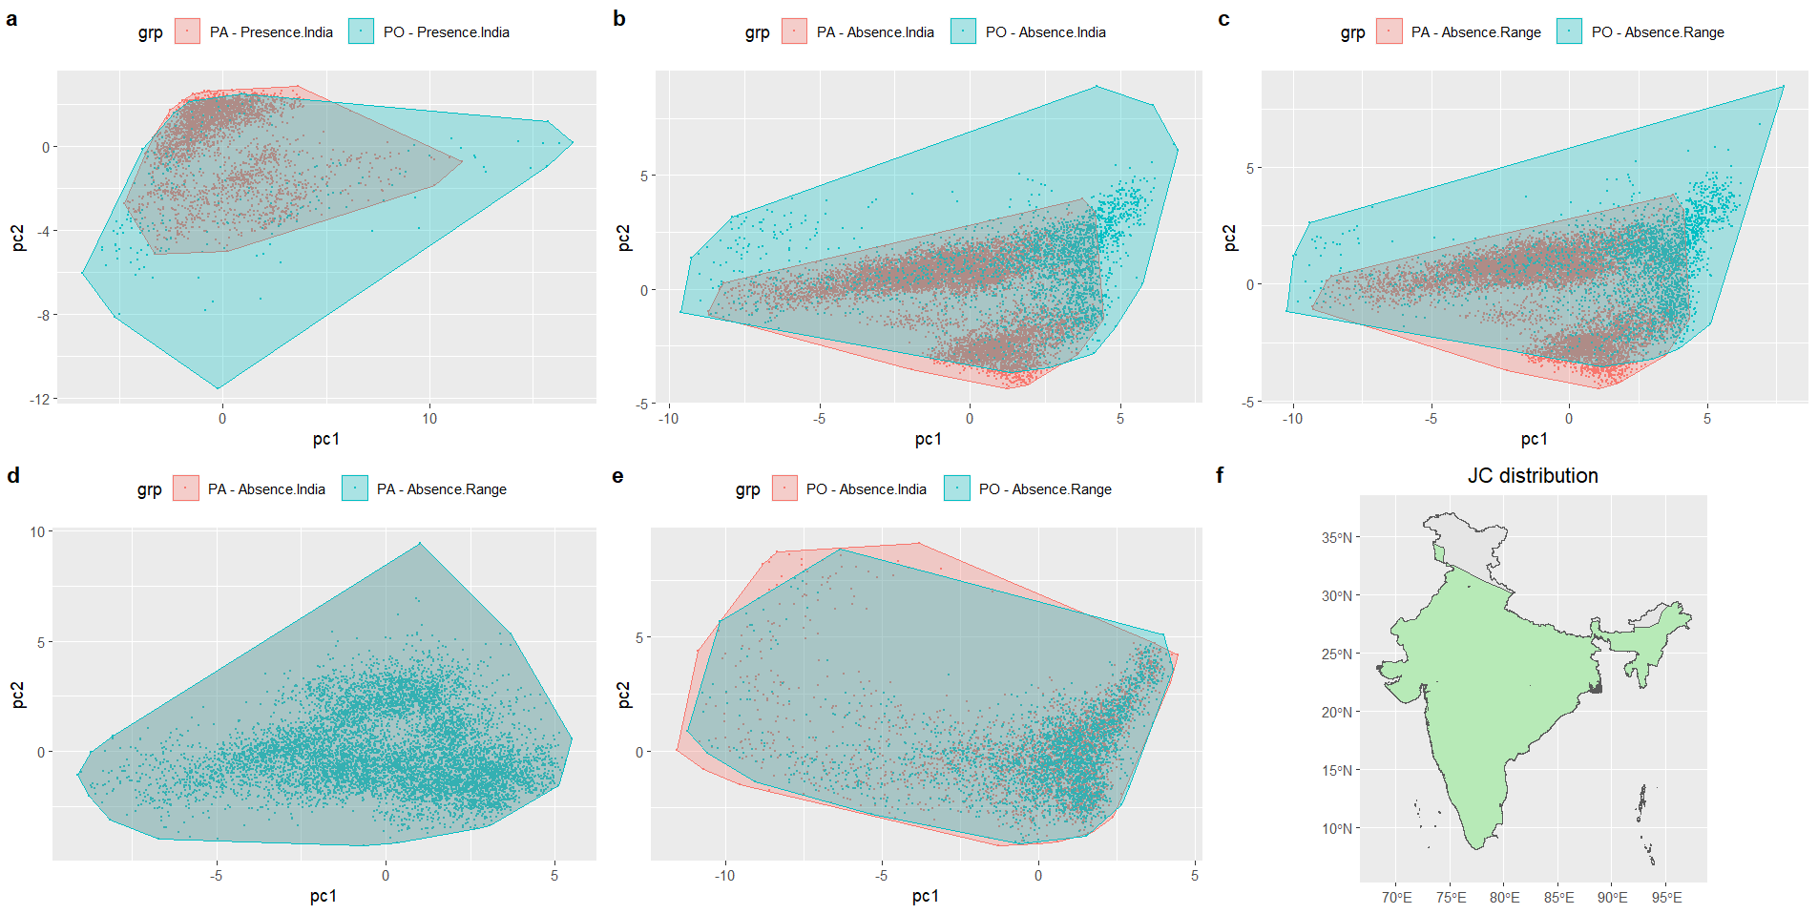

**Figure C1. PCA of sampled covariate space for different models for Jungle Cat.**

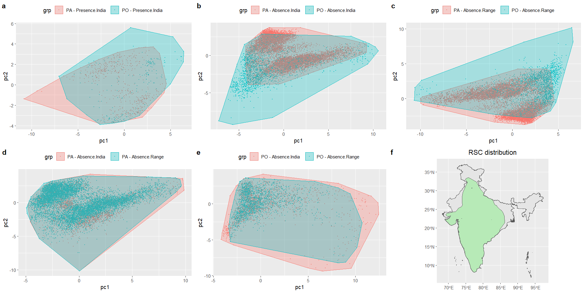

**Figure C2. PCA of sampled covariate space for different models for RSC.**

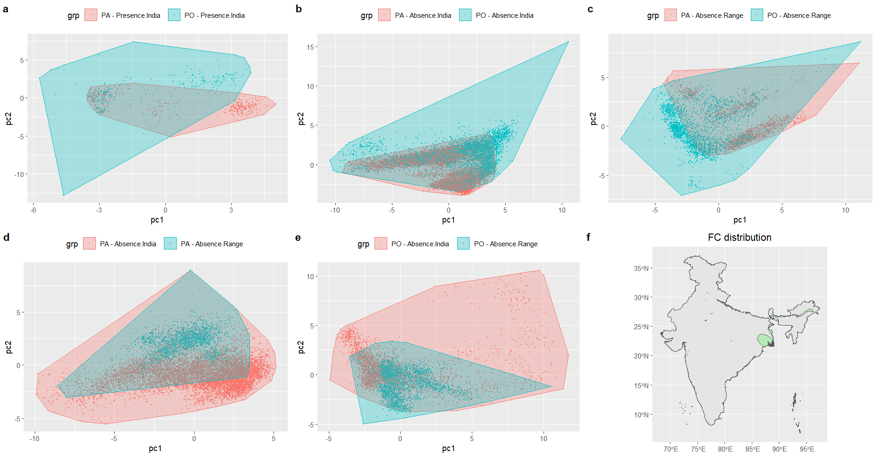

**Figure C3. PCA of sampled covariate space for different models for FC.**

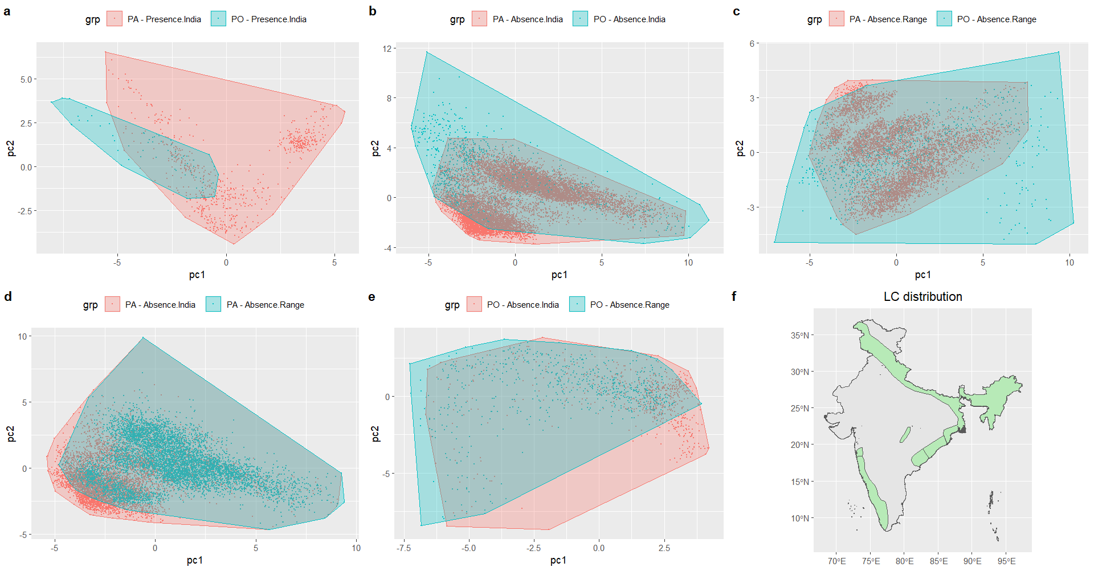

**Figure C4. PCA of sampled covariate space for different models for LC.**

**Niche overlap metrics: Schoener’s D and Hellinger’s I**

**Table C1. Niche overlap between PA and PB datasets for each species at different sampling extents**

|  |  |  |  |  |  |  |  |  |
| --- | --- | --- | --- | --- | --- | --- | --- | --- |
| **Overlap between PA-PB** | **India** | | | | **Range** | | | |
| **JC** | **RSC** | **LC** | **FC** | **JC** | **RSC** | **LC** | **FC** |
| **Schoener’s D** | 0.34 | 0.46 | 0.45 | 0.64 | 0.34 | 0.41 | 0.22 | 0.34 |
| **Hellinger’s I** | 0.55 | 0.73 | 0.63 | 0.82 | 0.55 | 0.7 | 0.38 | 0.53 |

**Table C2. Niche overlap between datasets with different sampling extents for each species**

|  |  |  |  |  |  |  |  |  |
| --- | --- | --- | --- | --- | --- | --- | --- | --- |
| **Overlap between India-Range** | **PA** | | | | **PB** | | | |
| **JC** | **RSC** | **LC** | **FC** | **JC** | **RSC** | **LC** | **FC** |
| **Schoener’s D** | 1 | 0.86 | 0.84 | 0.62 | 0.82 | 0.85 | 0.84 | 0.68 |
| **Hellinger’s I** | 1 | 0.97 | 0.95 | 0.87 | 0.93 | 0.97 | 0.91 | 0.9 |